**TEAM ID- PNT2022TMID28791**

PROJECT DEVELOPMENT DELIVERY OF SPRINT-2

Proposed architecture for smart track monitoring system.

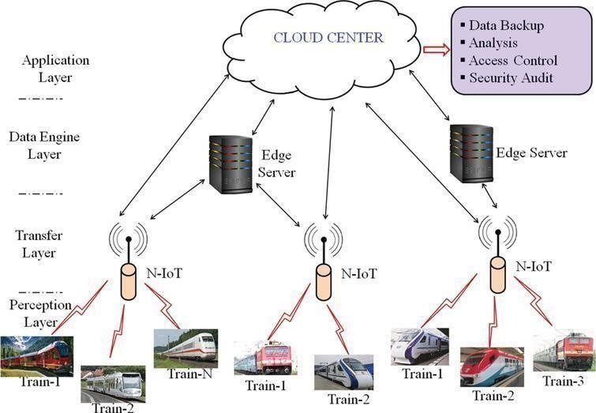

Structural health monitoring of railway tracks using IOT-based multi robot system:

